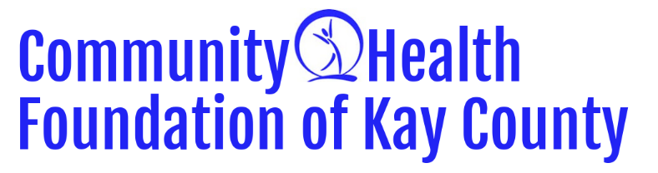
Organization Name: _________________________________________________________________________________________________
Organization Mailing Address: _____________________________________________________________________________________
Contact Person & Title: _____________________________________________________________________________________________
Phone Number: ________________________________________ Website: ___________________________________________________
E-mail address: ______________________________________________________________________________________________________
Tax ID/EIN Number: ____________________________________ Please provide a copy of your IRS designation letter showing you are a 501(c)3
Does your organization have an annual outside audit? Yes No
Organization’s Mission Statement: _________________________________________________________________________________
_______________________________________________________________________________________________________________________
_______________________________________________________________________________________________________________________
_______________________________________________________________________________________________________________________
Funds are being requested for (check one or more that best fits your funding request):
Salary Support Start-up costs Capital/ Equipment Community Education
Program/project support Other (please specify): ___________________________
Project dates: ________________________________________________________________________________________________________
Dollar amount requested: ___________________________________________________________________________________________
Will all requested funds be used this year (October 2026 - September 2027)? _____________________________________
Total program or project budget (attach copy): ____________________________________________________________________
Signature of chief staff person and the officer of the Board of Directors:
Chief Staff Person: ____________________________________ Board of Directors: ________________________________________
Print Name: ___________________________________________ Print Name: _______________________________________________
Signature: _____________________________________________ Signature: _________________________________________________
Title: __________________________________________________ Title: ______________________________________________________
Date: __________________________________________________ Date: ______________________________________________________

Please attach a document answering the following questions:
- Organization Information
Please provide a brief overview of your organization, the services you provide, and the population you serve.
- Project Summary
Please describe your program or project, including:
- What the project is
- Who it will serve
- The goals and expected outcomes
- Estimated number of people impacted
- Proposed Timeline/project duration
- Mission & Strategic Alignment
Please checkmark and explain how your project supports the Community Health Foundation's mission of improving the health of Kay County residents and how it aligns with one or more of the following strategic priorities:
Physical Activity Nutrition Mental Health Accessibility to Care Other
Explain:

- Project Budget
Please attach a detailed line-item budget for the proposed project. Include the total project cost, all anticipated sources of funding, and a clear description of how Community Health Foundation grant funds will be used. If applicable, note any in-kind contributions. Measurement & Evaluation
How will you measure the success and impact of this project? Please include any outcomes, data, or evaluation methods you plan to use.
- Evaluation & Measurable Outcomes: How will you measure the success of this project? Please identify at least 2–3 measurable outcomes and describe how and when data will be collected. Examples may include number of participants served, pre/post surveys, health improvements, attendance, screenings completed, or referrals made. Additional Funding
- Sustainability: Is this a one-time project or an ongoing program? If ongoing, please describe your long-term plan for sustaining this program beyond the grant period, including any future funding strategies or partnerships.
- Additional Funding: Have you requested or received funding from any other organization for this project? If yes, please identify the source(s) and amount(s). Is this a matching grant request? If you do not receive full funding from the Community Health Foundation, would you still proceed with the project? If so, how?
- Organizational Capacity: Does your organization have the staff, infrastructure, and experience necessary to implement this project successfully? Please briefly describe the key personnel or volunteers who will be responsible for carrying out this project.
☐ I understand that if funding is awarded, an outcome report must be completed and submitted by July 31st. The report will be available on the Community Health Foundation website in June. Failure to submit a completed outcome report may impact eligibility for future funding opportunities.
☐ I understand that our Executive Director might schedule a meeting after submission of the application to talk further in depth about the grant request.

